@RELATION conjunto\_entrenamiento\_datos

@ATTRIBUTE kpi\_tiket\_medio REAL

@ATTRIBUTE kpi\_cifra\_ventas REAL

@ATTRIBUTE kpi\_margen\_comercial REAL

@ATTRIBUTE kpi\_rotacion\_stock REAL

@ATTRIBUTE kpi\_coef\_rentabilidad REAL

@ATTRIBUTE kpi\_cobertura\_stock REAL

@ATTRIBUTE cantidad REAL

@ATTRIBUTE kpi\_anho REAL

@ATTRIBUTE kpi\_mes REAL

@ATTRIBUTE kpi\_semana REAL

@ATTRIBUTE resultado {'Nada','Poco','Medio','Mucho'}

@DATA

6.412,488500,20.766,0.377,38194,18.000,109,2013,12,49,Nada

3.667,247500,23.094,0.191,10896,5.643,55,2013,12,50,Nada

1.375,49500,18.586,0.021,190,6.145,11,2013,12,51,Nada

1.222,49500,23.737,0.015,181,12.480,11,2013,12,52,Nada

0.667,9000,31.131,0.003,8,27.390,2,2013,12,53,Nada

1.000,13500,31.131,0.005,20,79.750,3,2014,1,1,Nada

1.000,18000,20.727,0.008,30,111.188,4,2014,1,2,Nada

1.000,13500,23.737,0.009,29,131.000,3,2014,1,3,Nada

1.333,18000,16.655,0.018,54,78.300,4,2014,1,4,Nada

4.500,324000,31.145,0.389,39273,2.415,72,2015,10,42,Poco

5.370,652500,31.145,0.876,178047,3.778,145,2015,10,43,Nada

3.167,85500,31.145,0.110,2916,1.061,19,2015,10,44,Poco

4.300,193500,31.145,0.185,11146,3.229,43,2015,11,45,Nada

3.818,189000,31.145,0.221,13012,3.058,42,2015,11,46,Nada

4.786,238500,12.957,0.161,4977,4.875,67,2015,11,47,Nada

6.923,630000,11.472,0.314,22703,13.086,180,2015,11,48,Nada

5.407,511000,11.472,0.327,19190,5.014,146,2015,11,49,Nada

6.098,875000,11.472,0.880,88362,3.122,250,2015,12,50,Poco

6.806,738500,11.472,2.654,224854,0.828,211,2015,12,51,Medio

10.179,997500,11.455,1.588,181413,1.404,285,2015,12,53,Poco

7.037,665000,11.455,10.270,782312,0.154,190,2016,1,53,Medio

8.800,1078000,11.455,0.777,95919,0.221,308,2016,1,3,Medio

5.973,1568000,11.455,0.818,146832,7.588,448,2016,1,4,Nada

7.825,1095500,11.455,1.950,244714,1.258,313,2016,1,5,Poco

5.636,434000,11.455,0.193,9572,0.011,124,2016,2,6,Medio

6.595,854000,11.455,0.210,20506,4.353,244,2016,2,7,Poco

7.065,1137500,11.455,0.369,48093,4.599,325,2016,2,8,Poco

10.792,906500,11.455,0.441,45776,3.104,259,2016,2,9,Poco

6.968,756000,11.455,0.615,53290,1.659,216,2016,3,10,Poco

6.771,829500,11.455,1.888,179432,0.915,237,2016,3,11,Medio

8.250,577500,11.455,0.600,39690,0.029,165,2016,3,12,Medio

7.250,812000,11.455,0.543,50535,2.636,232,2016,3,13,Medio

5.750,805000,11.455,1.173,108204,1.472,230,2016,4,14,Poco

11.120,973000,11.454,1.823,203167,0.388,278,2016,4,15,Medio

7.276,738500,11.454,0.984,83210,0.908,211,2016,4,16,Medio

6.667,420000,11.455,0.242,11651,0.855,120,2016,4,17,Medio

7.886,966000,11.455,0.425,47056,3.872,276,2016,5,18,Poco

7.810,574000,11.455,0.381,25047,2.530,164,2016,5,19,Poco

7.345,745500,11.455,0.878,75005,1.870,213,2016,5,20,Poco

9.095,668500,11.455,1.394,106756,0.625,191,2016,5,21,Medio

6.821,668500,11.455,2.768,211965,0.729,191,2016,5,22,Medio

8.667,819000,11.455,0.352,33011,2.235,234,2016,6,24,Medio

6.286,308000,11.455,0.121,4259,4.282,88,2016,6,25,Nada

3.412,203000,11.455,0.149,3458,3.223,58,2016,6,26,Nada

1.143,28000,11.455,0.072,231,1.713,8,2016,7,27,Nada

7.600,532000,11.455,2.187,133275,0.097,152,2016,7,28,Medio

7.278,1001000,18.885,2.130,402667,1.844,262,2016,7,29,Poco

5.778,1248000,22.523,4.026,1131588,0.796,312,2016,7,30,Mucho

6.556,1416000,22.523,1.566,499550,0.178,354,2016,7,31,Medio

7.067,848000,22.523,0.700,133632,1.322,212,2016,8,32,Medio

6.300,756000,22.523,0.982,167176,0.673,189,2016,8,33,Medio

**Matriz de confusión**

|  |  |  |  |  |  |  |  |
| --- | --- | --- | --- | --- | --- | --- | --- |
|  |  | **Predicción (B)** | | | |  |  |
|  |  | a = Nada | b = Poco | c = Medio | d = Mucho |  |  |
| **Real (A)** | a = Nada | **95** | 4 | 0 | 0 | 99 | 0,6781 |
| b = Poco | 2 | **17** | 4 | 0 | 23 | 0,1575 |
| c = Medio | 0 | 4 | **15** | 2 | 21 | 0,1438 |
| d = Mucho | 0 | 0 | 0 | **3** | 3 | 0,0205 |
|  |  | 97 | 25 | 19 | 5 | 130 |  |
|  |  | 0,6644 | 0,1712 | 0,1301 | 0,0342 |  |  |

|  |  |
| --- | --- |
| Total Number of Instances | 146 |
| Correctly Classified Instances | 130 |
| Incorrectly Classified Instances | 16 |

|  |  |  |  |
| --- | --- | --- | --- |
| Exactitud | 0,890 | Exactitud = (TP + TN) / (TP + TN + FP + FN) | (95+17+15+3) / (95+17+15+3+4+4+2+2+4) |
| Precisión (Poco) | 0,680 | Precisión = (TP) / (TP + FP) | (17) / (17+4+4) |
| Sensibilidad o Recall (Poco) | 0,739 | Sensibilidad = (TP) / (TP + FN) | (17) / (17+2+4) |
| Medida F (Poco) | 0,708 | Medida = (2 \* Sensibilidad \* Precision) / (Sensibilidad + Precision) | (2\*0.739\*0.680) / (0.739+0.680) |

|  |  |  |  |
| --- | --- | --- | --- |
| P(A-Nada)\*P(B-Nada) | 0,451 | La probabilidad de que ambos evaluadores digan "Nada" al azar. |  |
| P(A-Poco)\*P(B-Poco) | 0,027 | La probabilidad de que ambos evaluadores digan "Poco" al azar. |  |
| P(A-Medio)\*P(B-Medio) | 0,019 | La probabilidad de que ambos evaluadores digan "Medio" al azar. |  |
| P(A-Mucho)\*P(B-Mucho) | 0,001 | La probabilidad de que ambos evaluadores digan "Mucho" al azar. |  |
| Pr(a) | 0,890 | Pr(a) = (95+17+15+3) / (95+17+15+3+4+4+2+2+4) | Pr(a) el acuerdo relativo observado entre examinadores, o el porcentaje de acuerdo observado. |
| Pr(e) | 0,497 | Pr(e) = 0.451 + 0.027 + 0.019 + 0.001 | Pr(e) es la probabilidad de que el acuerdo entre examinadores se deba al azar, o la probabilidad hipotética de acuerdo casual. |
| Kappa | 0,782 | kappa = (Pr(a) - Pr(e)) / (1 - Pr(e)) | El coeficiente kappa de Cohen (κ) es una estadística que mide el acuerdo entre evaluadores para los ítems cualitativos (categóricos). |

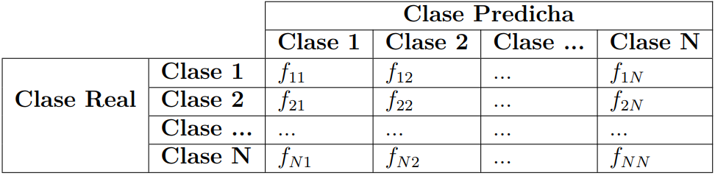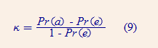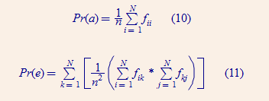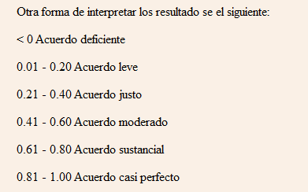C:\Users\Tecnologia\Documents\GitHub\tesisLibroBIML\Presentacion\Ayuda\formula_exactitud.png